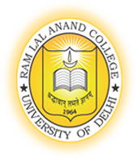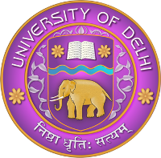
Faculty Profile
Ram Lal Anand College, University of Delhi
Accredited by NAAC with A+ Grade
ISO 21001: 2018 and ISO 9001: 2015
NIRF 2025 AI Rank - 90
Title | Dr. | Name: | Vishal Sharma |  | 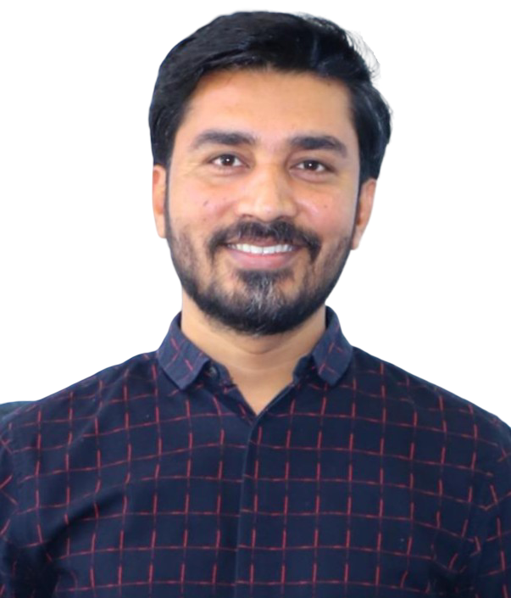
Department |  | Hindi Patrakarita Evam Jansanchar
Designation |  | Assistant Professor
Phone |  | 9411667299
Email |  | vishalsharma.bjmc@rla.du.ac.in
Institutional Web page |  | https://rlacollege.edu.in/Departments_bjmc.php#
Google Scholar ID |  | https://scholar.google.com/citations?hl=hi&user=xPDEVyMAAAAJ
ORCID ID |  | https://orcid.org/0000-0002-3769-5606
Vidwan ID |  | 131483
Educational Qualifications
Degree |  | Institution |  |  | Year
Ph.D. Mass Communication and Journalism |  | Central University of Himachal Pradesh, Dharamshala |  |  | 2021
M.Phil. Mass Communication and Journalism |  | BBA Central University, Lucknow |  |  | 2014
M.A. Mass Communication & Journalism |  | BBA Central University, Lucknow |  |  | 2013
Permanent/ Temporary/ Contractual/ Adhoc Teaching Experience
Designation |  | Institution |  | Duration | From | To | Nature
Assistant Professor |  | Ram Lal Anand College, University of Delhi |  | — | 14.10.2025 | Till Date | Permanent
Assistant Professor |  | Department of Journalism and Mass Communication, Chhatrapati Shahu Ji Maharaj University, Kanpur |  | 3 years 9 months | 2022 | 2025 | Contractual
Assistant Professor |  | UIMS, Chandigarh University. Chandigarh |  | 10 months | 2021 | 2022 | Regular
Industry Experience (If any)
Designation |  | Company |  | Duration | From | To
Reporter |  | Nav Bharat Times, Lucknow |  | 2 years 6 months | 2013 | 2016
Research Experience
Designation |  | Institution |  |  | From | To
Anil Agarwal Media Fellowship for Indian Journalist |  | Center for Science and Environment (CSE), New Delhi |  |  | 2015
Administrative Assignments
- Member, Academic and Executive Council, CSJM University, Kanpur
- Subject Convener, PhD Programme, CSJM University, Kanpur
- Member, Board of Studies, (Course) Department of Journalism and Mass Communication, CSJM University, Kanpur
- Convener, Board of Studies, (Course) Department of Journalism and Mass Communication, CSJM University, Kanpur
- Head, Department of Journalism and Mass Communication, CSJM University, Kanpur
- Media In-Charge/Official Spokesperson, CSJM University, Kanpur
- Assistant Director, Deen Dayal Shodh Kendra, CSJM University, Kanpur
- Assistant Proctor, CSJM University, Kanpur
- Member, Board of Studies, Chandigarh University
- Member, Yoga and Meditation Committee, RLA College, University of Delhi
- Member, Sports Committee, RLA College, University of Delhi
- Member, Samdrishti and Srijan Committee RLA College, University of Delhi

Areas of Interest / Specialisation
Political Communication, Digital Media, Communication Research, Print Media
Subjects Taught
Sports Journalism, Reporting and Editing, Content Writing, Advertising, Media Bhasha aur Anuvad, Samachar ki Avdharna aur Reporting, Sampadkiya Lekhan
Research Guidance (if any)
Two research scholars pursuing PhD (CSJM University, Kanpur)
Research Projects (Major Grants/Research Collaboration)
Publications
- “Gendered Ecologies on Stage: A Study of Three Indian Short Plays”, Indian Literature, No. 352, March-April 2026.
- “Young India, Social Networking Sites & Indian Politics”, Indian Journal of Political Science. 2012. https://www.jstor.org/stable/41856570
- “Expressions of Nationalism through Social Media Platforms, Indian Journal of Political Science, April-June 202
- नया मीडिया एवं भारतीय राष्ट्रवाद का बदलता स्वरूप, Journal of Acharya Narendra Dev Research Institute, 2019.
- सोशल मीडिया के दौर में भारतीय राष्ट्रवाद का सिंहावलोकन, अक्षरा, 2020
Chapters in books and e-chapters (Published)
Conference Organisation/ Presentations
- Invited Speaker, National Conference on Bhartiya Bhasha Parivar: Ekatv aur Ekatmakta, Indian Political Science Association
- Presented a paper titled “Attention for Future: Like, Share and Comment Culture and Its Influence on Children” in an International Workshop held at Tampere University, Finland.
- Presented a paper entitled "Internet and Nationalism: Emerging forms of Nationalism through Social Media" in an International Conference organized by IPSA, CCSU, Meerut
- Presented a paper in a National Seminar on “Globalization and youth in India: Perspectives, Issues and Challenges” held in BBA Central University Lucknow
- Presented a paper in National Conference on “Community Radio in India: Challenges and Possibilities of Information and Knowledge Sharing” held in Uttarakhand Open University Haldwani
- Presented a paper entitled "Integral Humanism of Deen Dayal Upadhyay for a Progressive Nation” during an International Conference organized by BBAU Central University Lucknow
- Presented a paper entitled “Social media se lekar shaikshanik sansthanon tak samkalin bharatiy rashtravad ka vimarsh” in a national seminar organized by Babasaheb Bhimrao Ambedkar University, Lucknow.

Awards and Distinctions
Association with Professional Bodies
Indian Political Science Association (IPSA)
Other Activities
- Invited Speaker for Yuva Vani and Fever FM, Himachal Pradesh

Signature of Faculty Member

